AMIT Graduation Project

Smart Home

Mostafa Magdy Hendawy

Group M12

Flow Chart of the Project

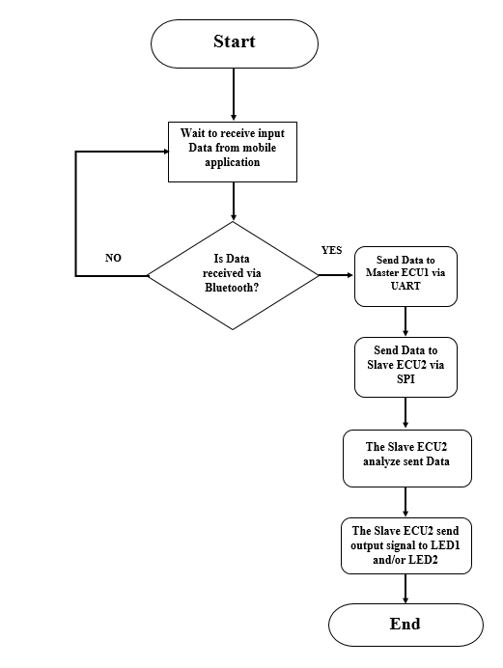

Code Architecture:

The Smart Home project is done using 2 Controllers, the Master and the Slave. The main purpose of the project is controlling a number of actuators remotely using Bluetooth device.

The project is divided into two sub projects.

The first project is for the Master ECU, it is used to receive data from the Bluetooth device via UART and then sends this data via SPI protocol to the Slave ECU.

The second project is for the Slave ECU, where it accepts data from its Master, processes it and then sends the output signals to the actuators which are represented by 2 LEDs in this project.

Using Bluetooth application on the mobile, the data can be sent to the Bluetooth module in the form of characters ‘a’, ‘b’, ‘c’, ‘d’, ‘e’ and ‘f’. The code works as follows:

When the data sent is character ‘a’: LED1 is switched on.

When the data sent is character ‘b’: LED1 is switched off.

When the data sent is character ‘c’: LED2 is switched on.

When the data sent is character ‘d’: LED2 is switched off.

When the data sent is character ‘e’: both LED1 & LED2 is switched on.

When the data sent is any other character: both LED1 & LED2 are switched off.

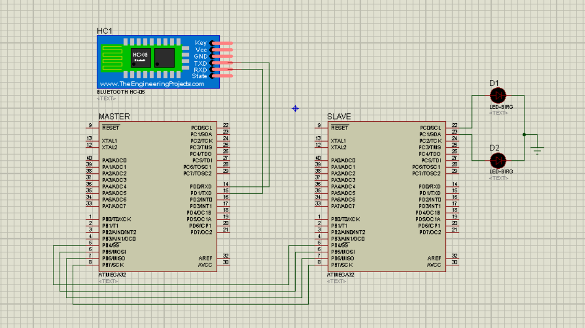Project Setup and Simulation using Protues: